Introduction

Purpose
The purpose of this document is to establish the Software Requirements Specification (SRS) for FitPro, a mobile fitness software that offers individualized programs, nutrition guidance, and a community of support to assist users reach their goals for fitness.

Project Scope
FitPro's software offers exercise plans depending on customer goals and preferences in an effort to provide consumers a personalized fitness experience. The site includes capabilities for meal planning, calorie tracking, and customized nutrition guidance in addition to workouts.

A wealth of articles covering fitness and nutrition subjects, live workout sessions with certified trainers, and progress monitoring for many fitness indicators are some of the key features. FitPro promotes user connection, creating a friendly environment where people may exchange support and experiences.

Aligning with business aims, the platform's main purpose is to encourage a balanced lifestyle. As a go-to resource for individualized fitness and well-being, FitPro hopes to develop into a comprehensive wellness platform that caters to a range of customer needs.

Intended Audience
The FitPro fitness app's development and implementation stakeholders are the target audience for this Software Requirements Specification (SRS) document. Among the intended audience are:
Project managers: As the primary managers of the FitPro project, they will find information in this document to assist them in managing expectations, working with stakeholders, and solving any possible problems.
Product Owner: he will obtain an understanding of the specific specifications, features, and functions anticipated in FitPro. The Product Owner is in charge of outlining the needs and vision for the product.
Development Team (Testers, Developers, and Designers): The technical group responsible for developing and overseeing the FitPro application is served by this department. The FitPro app's features, functionality, and performance requirements are explained in depth for designers, developers, and testers.
Users: FitPro's end users, who are those looking to increase their level of fitness, will get information about the app's advantages.
Documentation Writers: This section contains important details on the functional features of FitPro that need to be explained to end users for those in charge of writing user manuals, help guides, and other supporting documentation.

Document Organization:
This document is designed to serve different readers involved in the FitPro fitness app project. Start with the introductory sections for a general overview. Project Managers then dive into project management details, Product Owners explore product vision and requirements, and the Development Team find technical specifications. Users will discover information about FitPro's benefits and features, while Documentation Writers can focus on user communication. Following this sequence helps each reader grasp the relevant information for their role, making the document accessible and user-friendly.

Overall Description

Product Perspective

FitPro is a brand-new fitness software that provides consumers with a comprehensive solution rather than replacing anything. It all comes down to exercise, individualized nutration advice, and an active user base. Users receive personalized training schedules according to their objectives, degree of fitness, and equipment availability. The software offers nutration guidance, aids with meal planning, and tracks calories. The calories calculator's statistics make it simple for users to monitor their progress.

For a variety of interests and fitness levels, FitPro offers live sessions with professional instructors, going beyond solitary exercises. Expert articles on diet and exercise are also available to users. Users may interact through forums, chat, and experience sharing inside the app's supportive community.
Here's a quick look at our simple diagram. It shows the main parts, how they connect. Let's dive in!
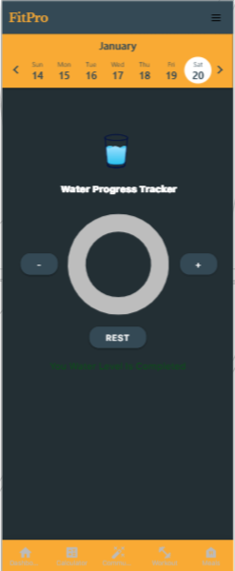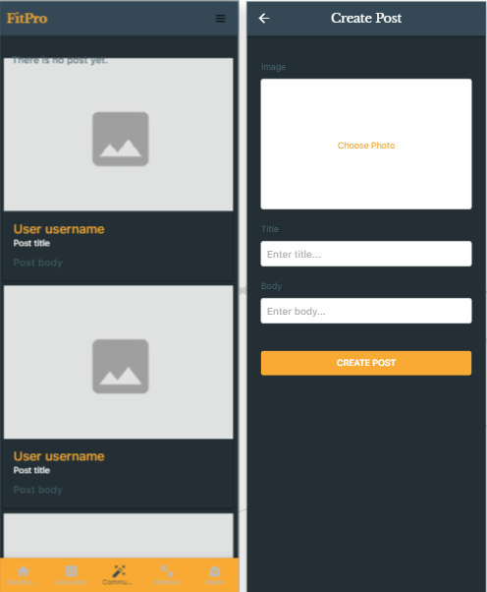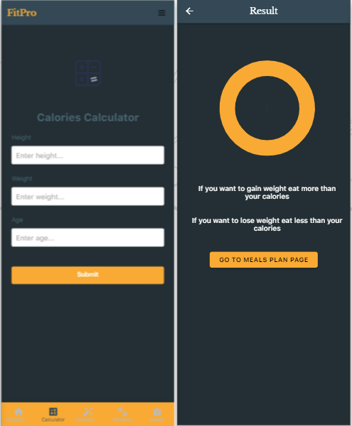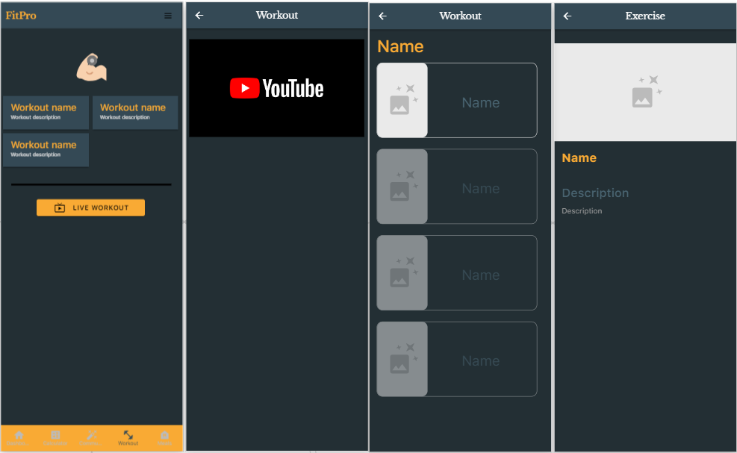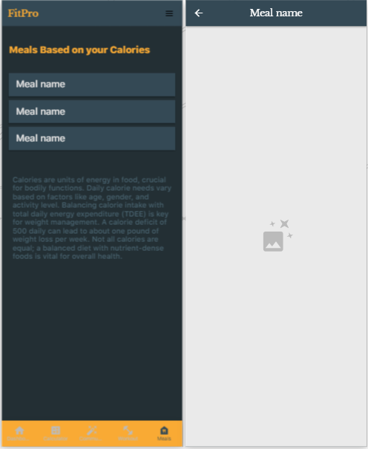

Product Features

FitPro's user-friendly foundation makes your fitness journey simpler. Onboarding is the first step; start by configuring your profile and fitness preferences. FitPro will provide customized food and exercise suggestions.

Workout Plans: Get access to exercise schedules that include descriptions for simple implementation.

Calorie Counter: Use the nutrition function to create personalized meal plans that are in line with your fitness objectives.

Progress Tracking: Use an all-inclusive progress tracking tool to monitor your drinking water level.

Live Workouts: For an engaging fitness experience, work out in real time with certified instructors.

Expert Articles: Read through a selection of regularly updated instructional articles about fitness and nutrition.

Community: In the forum or chat room, interact with other people to get support and encouragement.

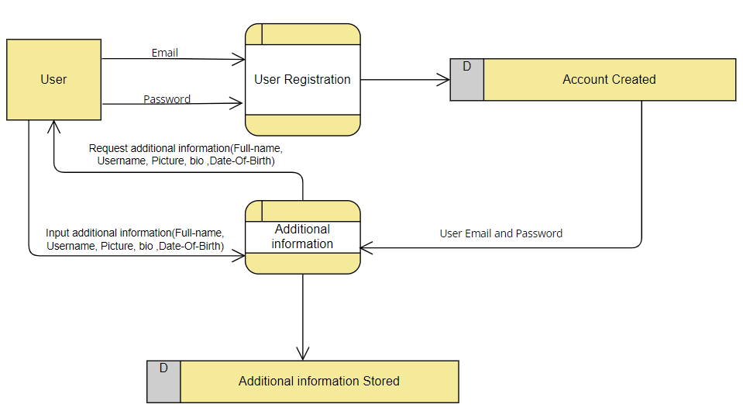
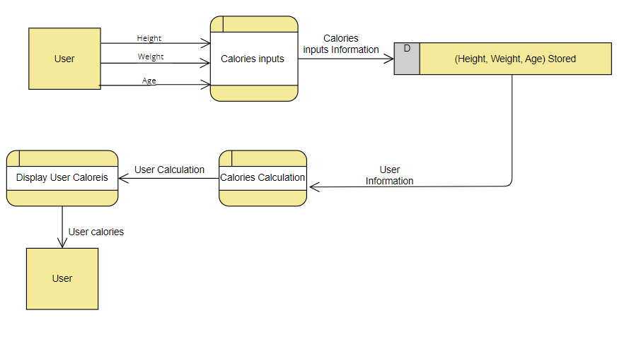

Operating Environment
In order to provide accessibility for a wide range of users, the program is designed to be compatible with several platforms and settings. Among the essential elements of the operating environment are:

Hardware Platform: FitPro is designed to work with a variety of hardware configurations, such as tablets, smartphones, and other handheld electronic devices. It makes use of contemporary hardware's capabilities to provide a snappy and responsive user experience.

Operating System: FitPro was designed to work with the most popular mobile operating systems, including Android and iOS.

Internet connectivity: To access live workouts, update information, and promote community interactions, FitPro needs internet connectivity for certain of its functions. The program is designed to run smoothly on a variety of network configurations.

FitPro's operating environment is flexible, allowing it to adjust to changes in technology while still offering a well-rounded and user-friendly workout experience.

Assumptions and Dependencies
Many things could affect how FitPro works, like the kinds of devices it can be used on, such as phones, tablets, and smartwatches. For FitPro to stay compatible with these devices, it needs to adjust when devices change or new ones come out. FitPro's design also considers rules about keeping your data safe and private. If these rules change, FitPro might need to change too.
FitPro also needs a good internet connection, especially for features like live workouts. If the internet isn't stable, it might affect how well live workouts work. The app also includes expert articles and other content, and whether these are available can depend on certain agreements. If those agreements change, the content in FitPro might need to change too.
The part of FitPro that stores and manages information (like your workout plans) should be able to handle more users and changing usage patterns. But if a lot of people start using FitPro differently, the way it stores information might need to be adjusted. FitPro will make money in future through things like ads or if people buy special features. The way it makes money might need to change if more people start using FitPro or if people's preferences change.
FitPro also relies on other things to make it better. For example, we will use special tools to connect with smartwatches and other devices. FitPro will also relies on certain systems to let people buy special features. If these tools or systems change, FitPro might need to change too. FitPro will use social media to let people log in and share their achievements. All these things are important to think about when making FitPro and keeping it working well.

System Features

1. User Registration and Profile Setup
1.1 Account Creation
Users can create accounts using email. (High priority).

1.1.1 Description and Priority
FitPro places a high priority on the User Registration and Account Creation function since it is the first step towards allowing users to interact with the platform. Users may easily create FitPro accounts with their email addresses thanks to this capability. Users are required to enter some details during the registration process, such as their email address, full name, username, age, height, and weight. The system enforces strict password rules to guarantee user account security.

User Registration and Account Creation is crucial (Benefit: 9) for personalizing fitness journeys, accessing tailored plans, and engaging with the FitPro community. It's generally straightforward (Penalty: 2), but complexity could deter some users. The moderate (cost:5) involves resources for account management and security. Mitigating a moderate (risk :6) requires robust password policies and security measures for user data protection.

1.1.2 Functional Requirements:

Req.1: Collect user information (email, Full-Name, Username, age, weight, height).
Req.2: Enforce strong password for account security.

1.1.3 Error Handling:

Provide users with obvious error messages during registration to remind them to fill up any missing fields if any are required.
Notify the user of the password requirements in the event that their password is weak and provide assistance in coming up with a strong one.

1.2 Profile Management
Users can update personal information, fitness goals, and preferences. High priority.

1.2.1 Description and Priority
With the help of this high-priority feature, FitPro users may easily change their name, age, and other personal information, resulting in a more customized and personalized workout experience.

This feature's high benefit rating (9) stems from the enhanced personalization it offers, positively impacting user engagement and satisfaction. While the potential penalty (3) is low, any issues in the updating process should be swiftly addressed to minimize inconvenience. With a moderate implementation cost (5), the development effort is reasonable, and a well-executed solution can effectively manage the associated risks (4), ensuring accurate and secure profile management.

1.2.2 Functional Requirements:
Req.1: Allow users to update profile information.
Req.2: Enable customization with profile pictures and fitness tracker integration.

1.2.3 Error Handling:
If the update request contains erroneous data (such as an age that is not a number or an improper profile image), error messages should be sent to direct the user to enter valid data.
To avoid unauthorized alterations, make sure that any changes made to sensitive information (such email addresses) are validated by extra authentication.

2. Fitness Plans
2.1 Workout Plan
FitPro generates workout plans tailored to goals. High priority.

2.2 Description and Priority:
Personalized fitness programs are a high-priority element of FitPro that are designed to give consumers workout routines that are exactly matched to their unique fitness objectives.

The substantial benefit rating (9) underscores the positive impact of this feature on user engagement and motivation. With a low associated penalty (2), the core functionality of generating personalized workout plans is seen as a valuable asset for users. While the implementation cost is moderate (6), reflecting the necessary development resources, the manageable risk (4) is primarily related to ensuring the accuracy of goal-tailored plans. Robust algorithms and validation processes are essential to mitigate potential risks and enhance the overall reliability of the generated workout plans.

2.3 Functional Requirements:
Req.1: Consider user goals, fitness level, and preferences for plan generation.
Req.2: Provide flexibility in workout duration and intensity.
Req.3: Include clear instructions.

2.4 Error Handling:
In case of unavailable equipment for a particular exercise, suggest alternative exercises or provide equipment substitution options.

3 Progress Reports
3.1 drinking water tracking
FitPro introduces a low-priority Progress Reports feature, enabling users to log drinking wate intake.

3.2 Description and Priority:
FitPro has a low-priority Progress Reports tool that lets customers track how much water they drink each day. Although it isn't a top priority function, customers may check and manage their hydration levels with the help of this feature.

FitPro's integration of water tracking (Benefit: 4) raises user awareness of hydration, which improves user well-being. The simple feature eliminates possible downsides with a low development cost (3) and negligible penalty (1). Standard validation procedures are permitted due to the minimal risk (2), guaranteeing correctness.

3.3 Functional Requirements:
Req.1: Enable drinking water tracking.

3.4 Error Handling:
Water Tracking: Ensure that users input valid water consumption data.

4. User Community
4.1 Posts Platform
Users connect with the FitPro community. Medium priority.

4.2 Description and Priority:
FitPro emphasizes community involvement inside the FitPro platform by launching the User Community feature, which allows users to interact with one another. This feature is given a medium priority, emphasizing its value in building relationships and community among FitPro users without being considered an essential component of the FitPro experience as a whole.
In comparison to items that are higher on the priority list, the User Community feature (Benefit: 5) has a moderate influence on fostering a feeling of community and support among FitPro members. Given that community interaction is often favorable, the potential penalty (2) is minimal. It has a medium priority and is not as important to the full FitPro functionality. The moderate implementation cost (4) pays for the materials needed to create and manage an interactive platform for users. With an emphasis on content management and maintaining a welcoming community, the related risk (3) is likewise moderate.

4.3 Functional Requirements:
Req.1: Create posts and share fitness experiences.
Req.2: Provide a platform for questions and support.

4.4 Error Handling:
Put in place content moderation to stop offensive or community guidelines-violating posts.
Inform users of any problems or interruptions in the chat platform's functionality and provide them with information on when service will be restored.

5. Expert Articles
5.1 Library of Articles
Explore expert-written articles on fitness and nutrition. Medium priority.

5.2 Description and Priority:
FitPro launches the Expert Articles service, which lets customers read articles written by qualified nutritionists and exercise professionals. This feature, which has a medium priority, provides insightful information without being seen as essential to the fundamental FitPro experience.

Expert Articles (Benefit: 6) offers insightful advice on diet and exercise from licensed professionals. Although it has a moderate priority and is impactful, it is not a high priority. Positive interaction with expert information is indicated by the low potential penalty (2). It has a medium priority and is not as important to FitPro's overall operation. The modest implementation cost (3) includes resources for keeping the article library up to date. The danger associated with (4) emphasizes how crucial material quality management is to improve the fitness and nutrition user experience.

5.3 Functional Requirements:
Req.1: Organize articles into categories for easy access.

5.4 Error Handling:
A helpful error notice should appear and you should be advised to try again later if there are server problems or the material cannot be loaded.
Each functionality's unique functional needs are broken out here, and error handling strategies for expected error situations or invalid inputs are also considered.

4. Nonfunctional Requirements
4.1 Performance Requirements
FitPro places a high value on a seamless and quick user experience. Exercise routines, and community interactions are among the features that are made to load quickly. We guarantee high availability, reducing server outages or maintenance periods, to reduce downtime. FitPro also improves data efficiency to meet the needs of customers with restricted data plans, particularly for video streaming and content delivery. For everyday actions, the FitPro app must react in a matter of seconds to provide a seamless user experience.

4.2 Security and Safety Requirements
Our user authentication system's safety standards place a high priority on preventing loss, illegal access, and potential injury from product use. To do this, we will impose the need for multi-factor authentication for more thorough user identity verification and the establishment of strong password regulations. Encryption protects sensitive user data while it is in transit and at rest, including financial information, health data, and personal information. Frequent security audits are carried out to find and fix vulnerabilities, and if sensitive data is accessed by unauthorized parties, prompt action is taken.

The system is built to abide with laws and regulations from outside sources, such as GDPR, and a dedicated compliance officer makes sure that compliance is always maintained. Furthermore, it's critical to achieve and maintain safety certifications like ISO 27001, and industry-specific security requirements need to be properly followed. Clear rules on managing sensitive information are supported by a thorough user education program that is undertaken to improve knowledge and adherence to security best practices. By taking these precautions, our user authentication system aims to reduce risks for users and their sensitive data while offering a safe and compliant environment.

Appendix A: Glossary

Personalized fitness plan: A workout routine generated specifically for the user's individual needs and goals.
Nutritional guidance: Suggestions for wholesome eating practices and meal plans customized to the individual's dietary requirements and objectives.
Tracking progress: keeping an eye on and documenting fitness data to gauge progress over time.
Live workout: A workout conducted in real time via the app's video interface under the guidance of a licensed trainer.
Expert article: Well-informed writing by licensed experts on diet, exercise, and related subjects.

Appendix B: Analysis Models
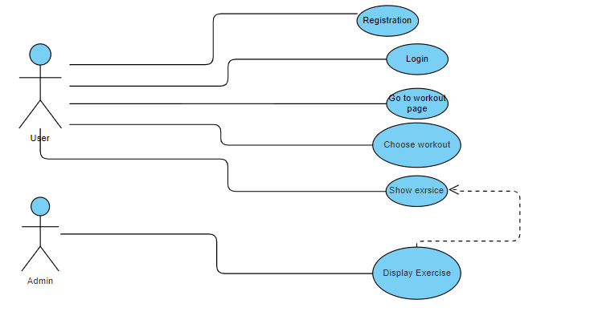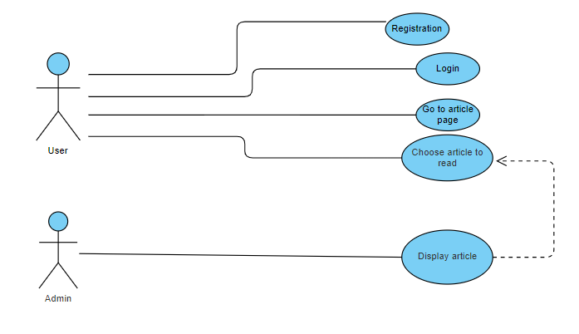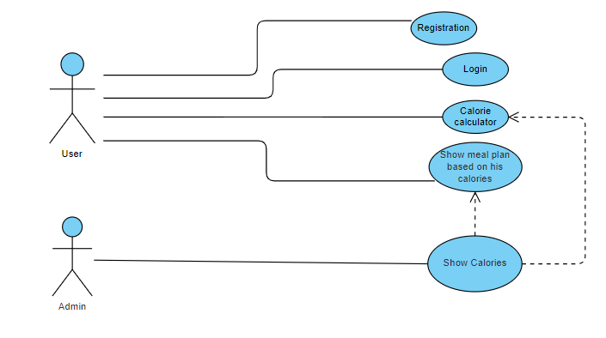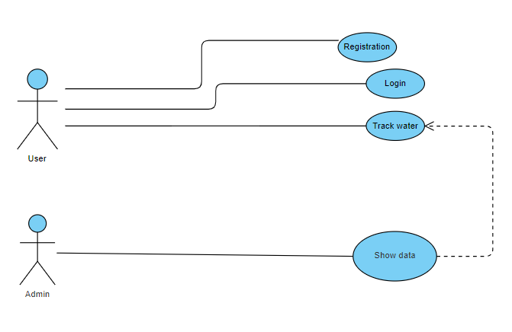

Appendix C: Data Dictionary
